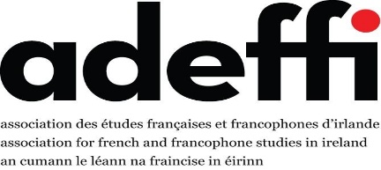

ADEFFI Spring Forum 04 April 2025
National University of Ireland, 49 Merrion Square & Online
Link to online room

Provisional Programme

10.30: Bienvenue & coffee/tea

10.45 Barry Nevin Space and place in French popular cinema of the 1950s
11.00 Corey Cribb Film and the Philosophy of Sense: On the Philosophical Turn in French Film Theory

11.15 Sarah Berthaud Global citizenship in Applied French: using textile and fashion studies.
11.30 Geraldine McGrath & Patricia Quigley International Business Degree with French at TUS Limerick ONLINE
11.45 Q&A / Discussion
12.00 Pause-café

12.15 Dervila Cooke Transcultural experience in France: literary representation
12.30 Francesca Counihan Marguerite Yourcenar et l'Amérique: exil et/ou engagement
12.45 Rosalind Silvester Ying Chen’s Ecocritical Discourse ONLINE
13.00 Cliona Hensey Ecocritical and ecopoetic approaches to Franco-Algerian literature ONLINE
13.15 Marion Krauthaker L’éco-poésie entre engagement esthétique et formel ONLINE
13.30 Q&A / Discussion
13.45 Lunch break

14.15 Michael G Kelly Revisiting Poetic Individuation in the Interwar Period
14.30 Ruth Whelan Élie Neau’s extraordinary voyage. Avant-première
14.45 Patrick Crowley It matters how we choose to remember: Imperalism’s Necropolitics & Erasures
15.00 Douglas Smith Infrastructural Imaginaries

15.15 James Hanrahan Origins and History
15.30 Q&A / Discussion
4 pm Conclusion

